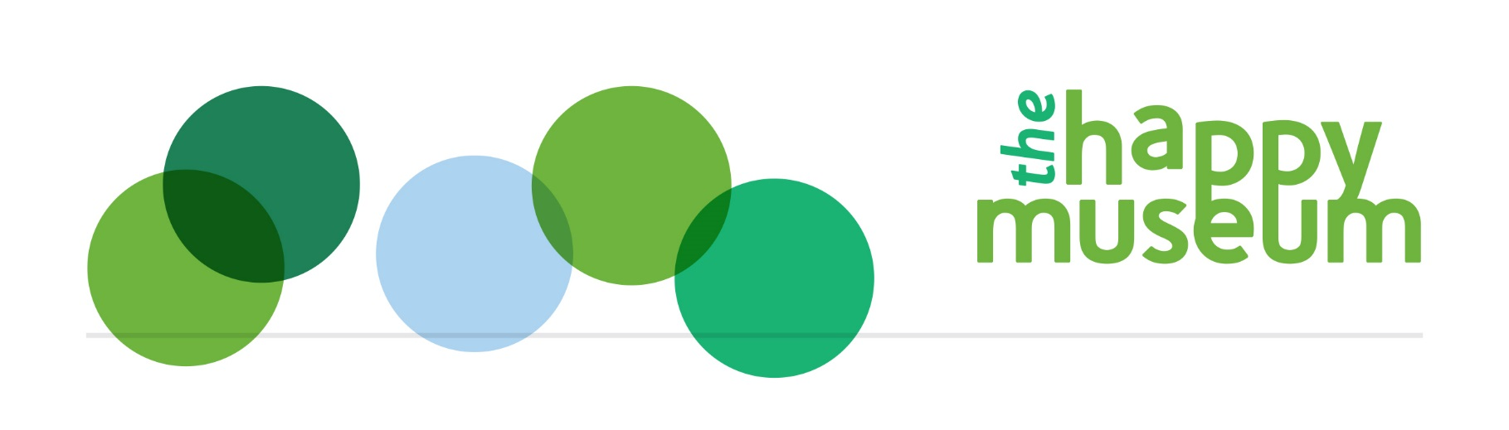

LIFE guidance
Learning, Interaction, Feelings and Environment in Happy Museums

Purpose

What the LIFE survey is for
LIFE is a survey to understand outcomes for volunteers, audience members, participants and staff in museums (VAPS), especially museums that want to use Happy Museum principles.
It measures wellbeing in terms of Learning, Interaction, Feelings and care for the Environment and surroundings.
It has been developed by Happy Museum using the action research of 22 commissioned museums, and with academic input from wellbeing economist Daniel Fujiwara of the LSE and Simetrica, and Kathryn Eccles of the Oxford Internet Institute.
It is hosted in Survey Monkey, and is free to use. There is a tutorial for museums to analyse their own data with more coming in Spring 2016. The data will also be analysed centrally every so often for wider sector learning.
LIFE’s particular strength is that it is:
- About community and place as well as individuals
- Uses a positive approach, or Asset Based Community Development (ABCD)
- Builds on action research and links to national datasets for comparison
- Is about both feelings and functioning (two key elements of wellbeing) and so is relevant to different types of museum programme.

Background
Many ‘Happy Museums’ used the Five Ways to Wellbeing to guide their wellbeing practice and similarly many have used WEMWBS to measure wellbeing. However the environmental objectives of Happy Museum are less well supported by guidance and tools. And at the same time, the two issues – wellbeing and care of the environment – are natural outcomes for museums that are involved in active stewardship.
LIFE intends to link these two outcomes, whilst also building on existing and well understood outcomes for museums: learning and interaction or relationships. This link is being made increasingly in the wider world, for example through concepts like ‘Stuffocation’ and the work of the Centre for Understanding Sustainable Prospertiy.
It provides an opportunity to look at these wellbeing outcomes alongside the different types of engagement with museums; as a volunteer, audience member, participant or member of staff – and against the different features of a museum fit for a sustainable future.
Here is the LIFE Survey, which you can share by email or text, or on a tablet in your museum.
Here is the accompanying Are you a Happy Museum Survey, which gives us information about your project or service to use when we are analysing data all together.

Guidance

Question purpose
- Q1-12 are outcome questions on the four outcomes, Learning, Interaction, Feelings and the Environment. Each outcome has three questions to ask about short term feelings, longer term feelings and functioning (which is related to community and place). These will be differently relevant for light touch or in-depth projects. The feelings (wellbeing) questions are asked first so that answers aren’t skewed by the other questions.
- Q13-20 are demographic questions to control for other factors (ie take out the affect of other factors) in looking at causality. They are used for regression analysis, except for…
- …Q16 on post codes which allows us to match individuals before and after and could also be used for Mosaic or Audience Agency analysis later, when we have a larger shared dataset. We put it here because it’s logical for the respondent.
- Q21 allows us centrally to allocate the dataset to the correct museum/project (alongside date, and if still not clear post codes)
- Q22 is for second level of causality testing to try and find out what it is that is making the difference (first level being demographics)
- Q23-24 are for third level of causality testing to try and find out in more depth what it is that is making the difference
- Q25 provides respondents with the opportunity to feedback generally

Data analysis
There will be three levels of self-analysis offered:
- Indicative results  to inform further learning  Some basic guidance and online tutorial on how to compare average ‘before’ scores with average ‘after’ scores on the four outcomes | A non-specialist introduction to average of before and after results. This does not give statistically robust information or account for other factors, but it gives an indication of outcomes, and a basis from which to explore what it was that made the difference.
- Significant change  but not proof of cause  Guidance and template into which you can copy your data to provide statistically significant evidence. | Coming shortly.  For people who want to take it further, this is a robust approach that will indicate whether change has been inentional rather than by chance using a t-test for statistical significance.
- Indication of cause and effect -  including significant change  A template with a macro (because it’s fiddly) into which you can copy your data to provide evidence of causality. | Coming shortly.  For people with strong research interest and who are data savvy, this is a quasi-experimental method.  It is a robust approach that will indicate causality using multiple regression analysis.  This also looks at whether the overarching wellbeing outcomes are associated with the other three outcomes.  It requires a dataset of 200-300.

General survey guidance

Data collection
- Run as many surveys as possible, with responses to every question
- If you can ask a control group who are similar to complete the survey – this could be the same people whilst not engaged with the museum
- Provide all replies, don’t cherry-pick
- Run the survey in a consistent way, ie all online, or all paper and at the same time and place for control groups as for those involved
- Where you can use a unique ID for before and after
- The survey is not created for people under 14 years of age

Analysis
- When we have 2-300 responses in a national dataset we will run central analysis to find out the different values of the Learning, Interaction, Feelings and Environmental outcomes
- We will analyse what works from information about what people are doing in the museum
- We will look for correlations between Feelings (happy, satisfied, worthwhile) and the other outcomes
For now
- Museums find their own indicative results using our online tutorial
- Museums will be able to do t-tests and regression analysis using our guidance soon

Questions

- How happy do you feel now?
- How satisfied are you with your life nowadays?
- To what extent do you think the things you do in your life are worthwhile?
- How much do you feel you've been learning in the last few hours?
- How interested are you in new things?
- How often in the last few weeks have you had a go at something new?
- How interested have you been in other people in the last few hours?
- How close do you feel to other people?
- How often in the last few weeks have you chosen to do activities with other people (beyond family and friends)?
- How much did you notice your surroundings or environment in the last few hours?
- How much do you generally feel you belong in your surroundings or environment?
- How often in the last few weeks have you done something to look after or appreciate your surroundings or environment?
- Your age group
- Your gender
- Where do you live?
- What is your postcode?
- What is your relationship status?
- In general would you say your health is:
- Please tell us what qualifications you hold (tick the highest applicable)
- Are you (employment questions)
- Please tell us who asked you to complete this survey; the person, organisation or project (if you know). <br>This will help us organise the answers we receive.
- You might have several of these roles, but what have you just been doing? (VAPS)
- Did any of these things feature in what you've been doing? For staff and volunteers
- A shared vision that focuses on wellbeing
- A shared 'Story of Change' that explains what you've been doing
- The creative use of time or resources, or creativity in the scope of what's been going on
- Measuring what really matters to people
- Use of everyone's potential
- Experimental working
- Plans that catered for change or discomfort in the people involved
- Shared 'ownership' of what's been going on
- Mutual benefit
- Work across hierarchies or teams
- Playfullness, creativity, physical activity or beauty
- Brokered relationships between you and others
- The benefits of being green beyond those to the environment - the social or financial benefits
- The organisation's unique resources, like its collection or building
- A caring attitude to people, place or planet
- Are there any other features you'd like to tell us about?
- As above, for audience and participants
- Is there anything else you'd like to say?
- If you would like us to tell you the results of this survey please give us your email address here

Warwick and Edinburgh Mental Well-being Scale.

