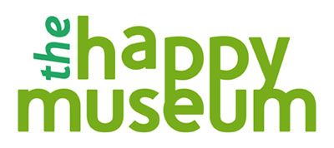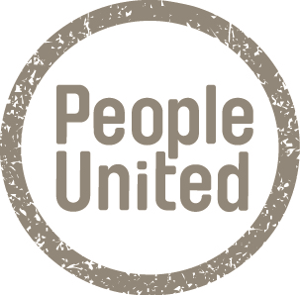

The team at Happy Museum is very excited about the potential of working in alliance with People United. Hilary Jennings and Tom Andrews have been meeting for some months to discuss areas of common ground and potential joint projects. These discussions led to People United hosting of the Happy Museum Away Day with the whole team in September 2014 from which a 5-year Happy Museum plan emerged.

Although having distinct missions and structures we share much common ground in thinking and approach to active citizenship, resilience and values of community and collaboration (as opposed to consumerism and commodification). Happy Museum will benefit greatly from the support of an established and respected NPO such as People United in this bridging year helping us to reflect, consolidate and build organisational capacity as a base for our 5 year plan. In the longer term a period of closer working will allow us to share networks and profile and raises the potential for future innovative joint projects.

The Happy Museum works to six key principles, one of which is 'pursue mutual relationships'. Our alliance with People United exemplifies this principle at the core of our mission for the next 5 years. We have already established a relationship of clarity and honesty with People United which we trust forms the basis of ongoing collaboration and the opportunity to learn from one another at a time of great change in the world and our capacities to respond creatively.

Happy Museum – November 2014

People United is delighted to have the opportunity to support, work with, and learn from Happy Museum. As a long-term admirer of their pioneering work, we are excited about the possibilities of a shared working relationship.

Central to our mission is our role as a catalyst and enabler. We do not want to constrain or stifle what Happy Museum does best; instead we want to provide the space, support and structure to enable Happy Museum to progress sustainably into their next phase.

People United will play a number of roles: holding and supporting (activity and financial reporting, monitoring and staff support), developing (helping the transition to a clear and resilient structure) and collaborating (advice and sounding board for future plans and content). We will draw up a clear agreement and understanding of our relationship.

People United will also gain from this alliance. It will allow us to expand our profile, audience and reach, it will enable us to learn, it will support our own resilience, and it will sow the seeds of new work and activities that can cross disciplines. Finally, we are looking forward to working with colleagues that share our values, and together we hope that our mutual support can inspire others and demonstrate a cooperative model of resilience.

People United – November 2014

