BACK TO THE FUTURE? – by Esme Ward

I want to share a radical vision for museums….I want to take us back to the future – to remind us what we might learn from those who have gone before us.

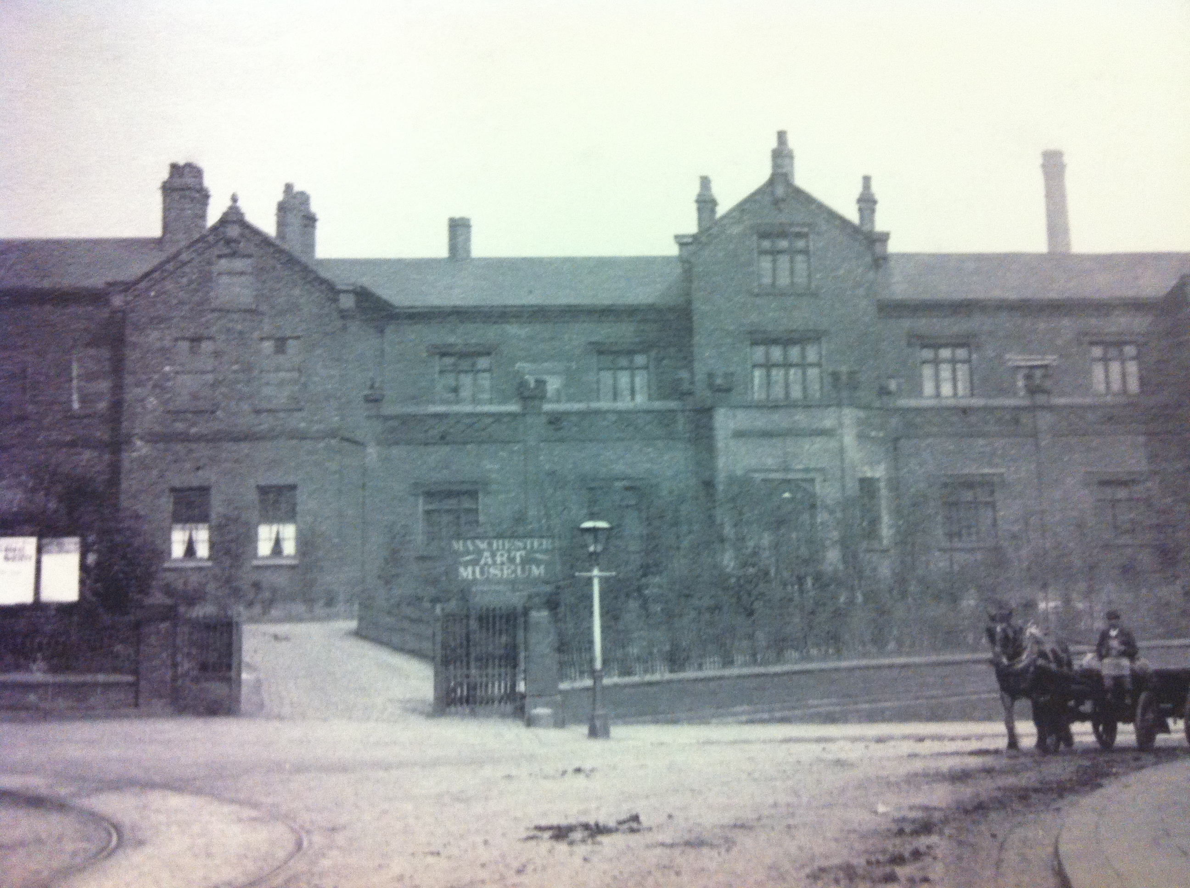

I want to revisit the Manchester Art Museum, opened in Ancoats in 1886 by pioneering philanthropist Thomas Coglan Horsfall . When the Art Museum opened, its rooms, they were variously dedicated to painting, sculpture, nature, architecture and domestic arts and together attempted to provide a chronological narrative of art.
The Museum started as essentially a Ruskinian experiment in civic engagement and yet John Ruskin believed Manchester was beyond help - too big, too squalid, too industrial, too far from nature.

Ancoats in the 1880s was not a desirable place to settle – yet it was the centre of a social experiment (saw the rise of Manchester Settlement in partnership with UoM)– with Horsfall’s museum at the centre, bringing beauty to the people of treeless Ancoats.

So – I’d like to consider the main aims of MUSEUMS CHANGE LIVES with direct reference to Horsfall’s vision and some of the extraordinary things that happened there..

1. MUSEUMS INSPIRE PEOPLE AND IDEAS

Horsfall insisted his main aim was INSPIRATION
He wanted to be at the forefront of developments in art education. He was an influential advocate for learning outside the classroom. In Horsfall’s world, when you believe in things, you have to take action and stand up for them. So he took a class of children down to London to lobby parliament and ensure that learning in the Museum was valued. In 1895 he obtained an amendment of the Education Code to allow schoolchildren to visit museums and galleries in school hours as part of their education.

He particularly wanted to work with those who had least – children with limited access to books. He took collections out of the museum and beyond its walls to where it can and did make a difference. There was an innovative picture loan scheme for schools which in its first year (1894) circulated over 200 collections to local schools.

An early focus was children with disabilities. By 1898, regular Santa Fina (named after an Italian disabled girl Fina da Cardi) parties were held. One of the Museum volunteers mapped out the homes of all disabled children within a ¾ mile radius of the museum.

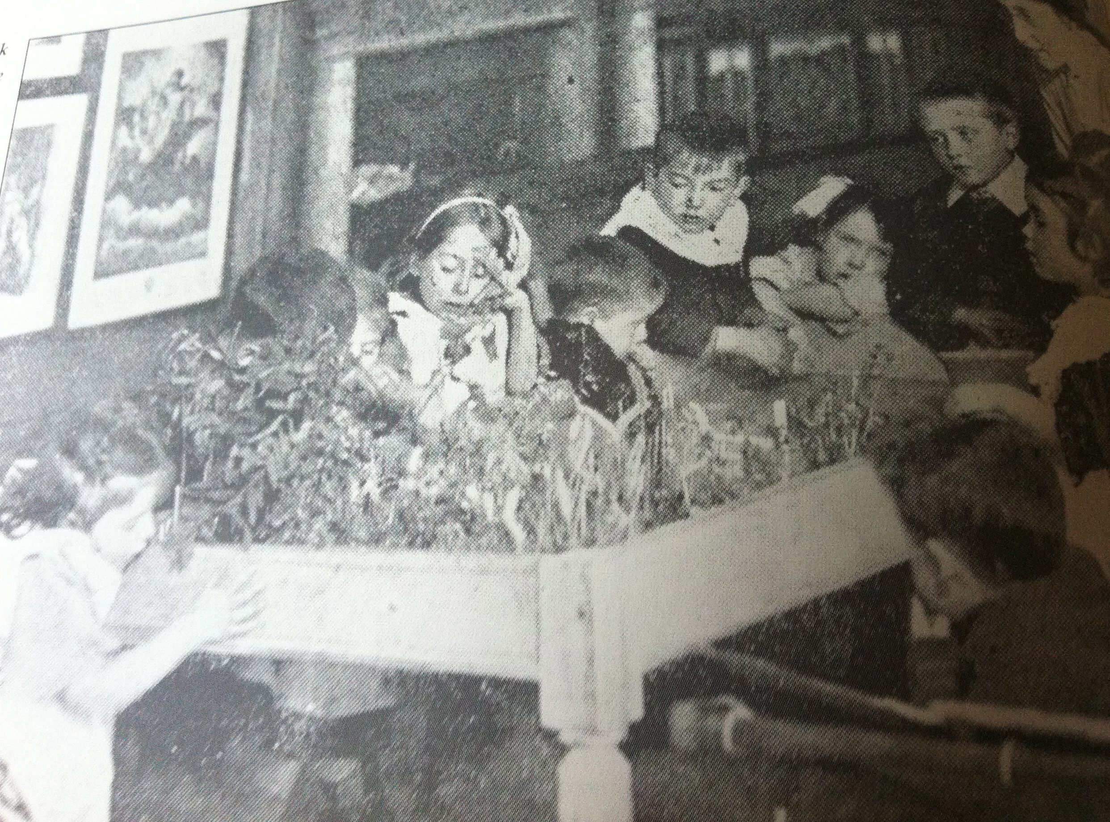

Santa Fina provided activities to end isolation and Museum staff once again lobbied in parliament in recognition of special educational needs. (Eventually, a special school was set up in 1911).

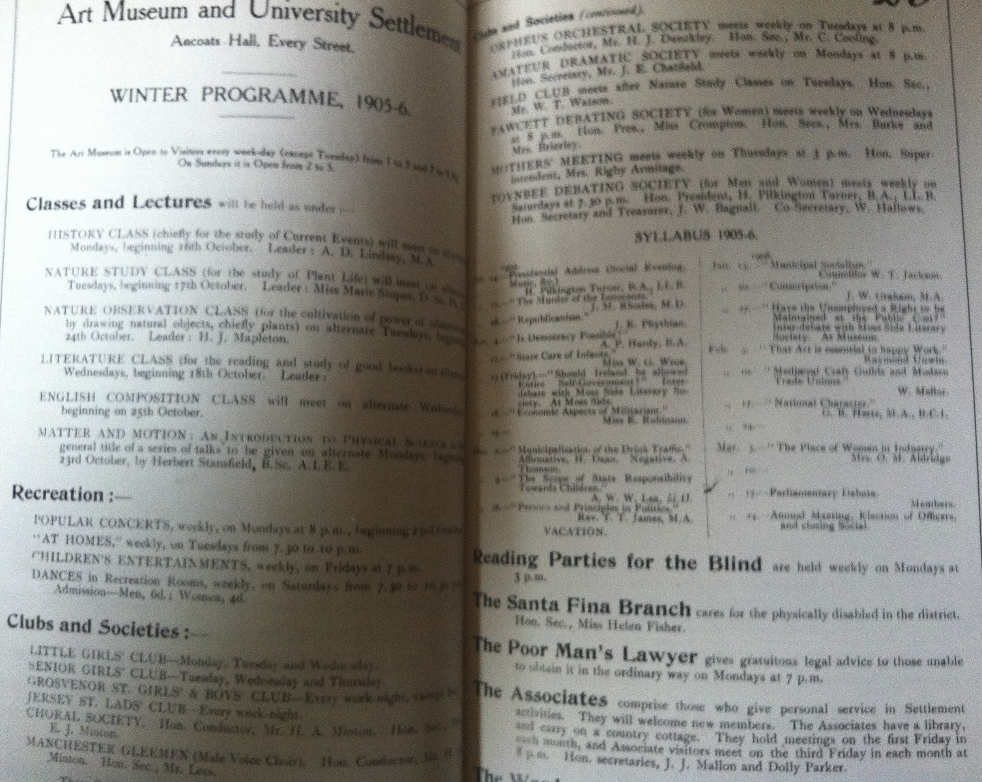

Horsfall wanted his museum to inspire learning.
The Museum boasted a Model Workmen’s Room which spawned craft classes in woodwork and drawing, Paintings of nearby beauty spots breathed life into an associated rambling club. Free music, lectures and entertainments on weekday evenings and Sunday afternoons proved popular, as did children’s concerts and readings. From 1892, a new concert hall was built to hold 600 people.

Horsfall wanted his museum to connect to contemporary life. History classes focused on the study of current events, the successful series of Monday popular lectures were given by leading university academics, debating societies reflected the political concerns of the day, the Museum even had a resident Poor Man’s Lawyer and a team called the Associates based at the Museum, who gave personal advice and social support to local people.

Because you see, Horsfall believed

MUSEUMS CREATE BETTER PLACES

Horsfall did not expect the museum to change the world, but to play a part in improving where people live, alongside better housing, more parks and recreational opportunities.

As such, it was located close to peoples homes - open until 10 at night and on Sundays so working people could visit.
In addition to the many different clubs (for adult learning - walking, singing, woodcarving) and events, young people were a priority. Junior Girls and Boys clubs were oversubscribed - a hundred + at night. A Junior Associate Members Group (Youth Board as we might now know it) for 16-30 year olds was linked to Juvenile Employment Exchange, with a focus on developing technical skills and employability

Family learning was embedded in the work of the museum. Infant mortality rates were high and maternal health was poor. An At Homes programme for families started in 1898 - and the social role of the museum came to the fore as more activities for the whole family were developed.

Great example of this - Saturday 24 October 1908, sale of bulbs and plants to brighten the backyards of Ancoats. The day included an exhibition of plants grown from bulbs and linked to the Museum’s own collection of paintings and specimens as well as inviting visitors to bring in their own collections.

The Museum had already reached out to the people, and it was natural that a new university settlement should ally itself to his foundational work. So, events of this kind were also attended by Settlement staff and health visitors who gave lectures on hygiene, sanitation and cookery to the families who came.

MUSEUMS ENHANCE WELLBEING

Horsfall believed museums had a role to enhance wellbeing though he wouldn’t have recognised this terminology. He held a distinctly Victorian Christian belief in the redemptive power of art and believed his Museum could widen the horizons and encourage visitors ‘to think nobly of the world and its maker’

“Show people the best pictures you can get of common things…so they notice the beauty of form, of colour…so when they next see the thing the picture represented, they will see the beauty in it”

So, in his museum, oil studies of ash trees in summer and winter were displayed with examples of real leaves alongside them, it distressed Horsfall that city children knew little of changing seasons.
Horsfall believed…
“Be aware of beauty and the wider world, it will give you the mental resources needed to find your way in life”.

Horsfall was, of course, a man of and beyond his time. Although his notion of progress and moral beauty sits uncomfortably with todays world, his vision of museums as engines of civic engagement is as relevant and powerful as ever…so I’ll leave you with a comment from the 1904 Annual Report;

It is not enough that in our rooms tired people may find pictures and other beautiful objects among which they may forget their weariness – or that from time to time Concerts, At Homes, and other gatherings bring the refreshment of music and good company to our neighbours… Alongside these other activities, therefore, we must develop and stimulate a healthy and vigorous sense of citizenship, which in time will find its expression in the work of our municipality.

(Manchester Art Museum and University Settlement Annual Report 1904: 10.)

or as we might put it… MUSEUMS CHANGE LIVES.

