A Happy Museum for the future – by Hilary Jennings

This presentation grounds the development of a new museum service in the context of ‘Museums Make Better Places’ and also draws on thinking behind the Happy Museum Project.

An increasing number of academics, economists and ecologists are identifying the vital linkage between sustainability and wellbeing and shedding new light on how thinking of these two issues in conjunction might offer a key to providing better places to live, both now and in the future. The Happy Museum vision is of the contribution museums might make to a sustainable future by fostering wellbeing that doesn’t cost the Earth. It is not primarily about individual health and wellbeing but comes further upstream, helping museums support wellbeing in society.

In creating a new City we must first look to its future – and the global context in which we hope it will develop and thrive.

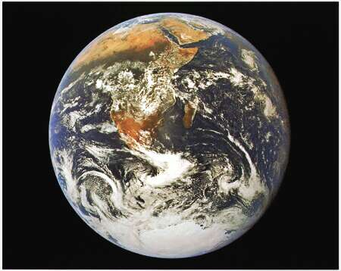

This is one of the first pictures taken of the earth from space. It represents the first time man was fully confronted with the fragility of the Earth amid the vast expanse of space. It was a clear message of the finite nature of our home planet and the moment has been credited with the birth of the modern environmental movement – with Friends of the Earth and Greenpeace setting up within two years.

Nearly 50 years since that photo was taken, however, we continue to treat the planet like there is no tomorrow. We have entered a new geological era – the Anthropocene – an era defined by the impact of humanity on our ecosystem. Impact which includes climate change, loss of biodiversity, ocean acidification, soil degredation and resource depletion.

Underpinning much of this impact is the exponential growth in our levels of consumption - which are driving us beyond the natural limits of our planet. Research by the Global Footprint Network suggests if consumption levels worldwide were the same as the current rate of the UK - we would require the resources of 3.5 planets to meet our needs.

But economic growth – or GDP – is currently the way we measure societal progress. However it has some crucial flaws. It encourages resource depletion through a focus on growth - and can’t differentiate between spending on good things (like education) and terrible things (like the rebuilding required after a natural disaster). It doesn’t measure services that nature provides, such as fresh water, or those without a market price, such as raising children. As Robert Kennedy once put it, GDP measures everything “except that which makes life worthwhile.”

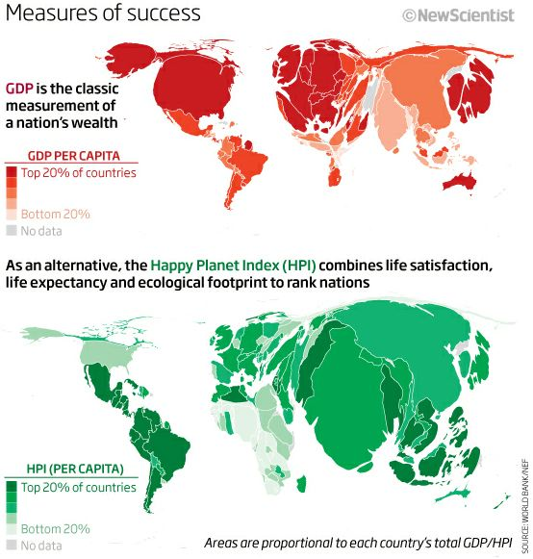

In addition - despite decades of economic growth our general wellbeing has flat-lined and inequality is rising. In the USA the richest 20% control 80% of the wealth, with a similar figure in the UK and getting worse. Meanwhile there is compelling research from academics like Wilkinson and Pickett that more equal societies do better. Their book, The Spirit Level pulls together a weight of research worldwide to demonstrate that the wellbeing of our societies is truly dependent on greater equality.

We need to recognise the finite limits of our planet, look long and hard at our levels of consumption and focus on a fair distribution of resources to meet both our current and our future needs.

Countries around the world – including the UK – are investigating other measures of progress that include a focus on what truly makes a society ‘well’. The Happy Planet Index developed by the New Economics Foundation also measures countries on their ability to pursue good environmental stewardship, to foster strong communal relationships and promote mental well-ness.

Happy Museum proposes that a city experiencing high levels of well-being would be first and foremost a good place to live. Applying learning from our existing project commissions, we would create a new museum where people could learn new things, play, make friends, give something back and have their spirits lifted and challenged.

However happiness will be short-lived if we achieve wellbeing for this generation of the city at the environmental expense of future generations.

Consequently we would focus on Creating the conditions for wellbeing - whilst at the same time valuing the environment - and being a steward of the future - as well as the past.

In Museums Change Lives it suggests that ‘collections contain evidence about past environments and can suggest creative solutions for society’s future’.

The museum would interrogate the history of the city’s site, and its incoming inhabitants, to help them better understand the interactions between the local and the global and between this present moment and our longer past and deeper future.

We would use our emerging collections and interpretation to encourage civic debate around fundamental questions such as:

What do we eat? How do we move around? How do we stay warm and safe?

How do we express ourselves emotionally and spiritually? Where do we find joy?

What do we need? How do we best use what we already have and perhaps most importantly - How much is enough?

We would seek to provide our new citizens with the space, and the context, to collectively imagine a different future.

A meaningful civic realm is a necessity for any new city to survive and thrive.

As Alex Steffen - a leading voice on social innovation – said recently - "Being a place people can make a difference could become a major competitive advantage for cities" ‘In cities people can acknowledge that they have direct mutual interests, and that their self-interest can only usually be served while addressing the common good. Everyone’s in it together.

Our new museum would use its development to encourage individuals to be more active within civic society (new museum staff included) at the same time ensuring the museum reflects the concerns of the city’s growing community.

We would investigate what the past tells us about human capacity to adapt and thrive and ask ourselves - what values, skills and qualities do we bring to the city? What do we leave behind?

A city in the process of formation will be by default a ferment of new institutions, groups and interests.

We would place the museum’s development at the centre of that process, engaging both with its history and its emerging future – helping build a narrative between the two.

We would build strong mutual relationships with the city’s emerging institutions and communities, engaging them directly in the design and creation of the new museum and its collection. We would seek to be a neutral and trusted public space for the seeding of new community groupings to support the growing city. Structurally we would consider the possibility of developing as a mutual organisation, or a co-operative.

We believe that the museum has a real opportunity to help imagine a positive future where we might consume less, be more mindful of our relationship with the environment, and create a more equal but no less interesting world. Our vision is of a museum which is not only an inclusive institution but a participative one in which individuals are not only consumers or beneficiaries but co-creators of their own space - where they can ponder life’s complexities and think about the world differently.
It could be argued that these are lofty ambitions, beyond the scope of, and perhaps a diversion from, the core purpose of museums. We believe that no country, city, institution or indeed individual should hold themselves apart from the challenges which face us all – and in fact that by engaging with them together we might create a museum, city and society worthy of our collective energy and imagination.

