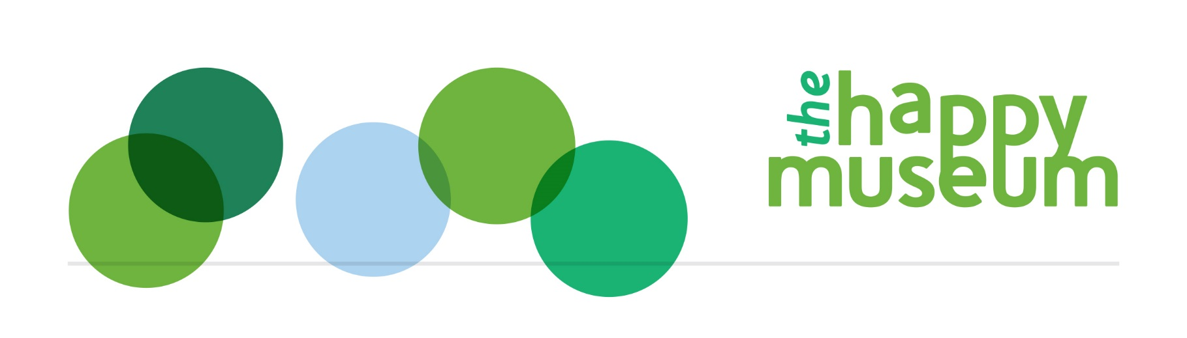

Cultural LIFE research

An introduction to The LIFE Survey
Learning, Interaction, Feelings and Environmental outcomes for cultural wellbeing
www.TheLIFESurvey.org

A free resource to measure your impact on cultural wellbeing
Cultural LIFE is a free to join research project into cultural wellbeing, which will help you to evidence the impact of your service or project robustly. It is especially useful for organisations that want to encourage participation and activism, and that are working with their community, neighbourhood or with the wider environment. Do you want to know:
- Is our service making a difference to people and how significantly, in terms of their Learning, Interactions, Feelings and care for the Environment; LIFE?
- Who is coming to our programmes? How representative are they of the local area? Are people from different backgrounds (different demographics) having a better or worse experience than each other?
- What kind of activity makes the most difference? Does participation or being an audience make more difference?
- Do staff and volunteers have positive outcomes?
- Is there a relationship between people’s Feelings (wellbeing) and other outcomes related to Learning, Interaction and care for the Environment? Can we find out about the ‘causal effect’, that is which is causing which?
- What is the value of the individual outcomes to people?
If you want to answer these questions you might want to take part. You can use the survey straight away by signing up at www.TheLIFESurvey.org. If you want to be part of the centralised analysis we are planning please complete https://www.surveymonkey.co.uk/r/Measuring_Cultural_LIFE so we can begin to communicate.
The work has been developed by the national campaign Happy Museums in partnership with happiness economist Daniel Fujiwara, with Oxford University and lately in partnership with Social Value UK and MB Associates. We worked with 22 museums over two years to refine the content, and the questions link to national data for ease of comparison. It contributes to a Knowledge Exchange project with Oxford Internet Institute in autumn 2017. In 2018 we hope to be working in partnership with the Audience Agency too.
The LIFE Survey is an online questionnaire accessed via an app, that collects information about outcomes for participants, audiences or volunteers and staff. Coupled with diversity questions the results mean you can see how wellbeing results compare with local averages as well as who is coming and how your team is made up.
The survey measures wellbeing in terms of Learning, Interaction, Feelings and care for the Environment and surroundings. It is different from other wellbeing measures that come from a health background, because it is about the community not just individuals, focuses on our assets more than our weaknesses and asks about our ‘functioning’ as well as ‘feelings’ (two recognised types of wellbeing).
NB the survey is not yet designed for use with young people under 14.
Following on from our knowledge exchange work, the LIFE Survey will be accompanied by a recommended menu of more interactive tools that can create a holistic evaluation approach.
There are two opportunities for data analysis – you can do either or both:
- You can download your data directly and analyse as you see fit (you can use our online tutorial for simple analysis, which was developed for the previous Survey Monkey version but still holds true)
- You can wait for our central statistical analysis when we will be considering all the data together probably twice a year, using some more robust approaches to get closer to proving cause and effect.

Guidance

Using the app
- Sign up to the app, choose a password for your organisation and set up as many surveys as you want, each with a name that makes sense to you so you can organise your information gathering, for example Festival2017 or Staff-August17: www.TheLIFESurvey.org
- Send us a short survey so that we know what sorts of projects are using the app https://www.surveymonkey.co.uk/r/CulturalLIFE
There are two types of survey that you can set up for your organisation:
- An anonymous collection method useful for audiences or festival type environments, where you can signpost people to the url
- A named version for smaller, participant type activity, which has the benefit that you only have to ask demographic questions once, and which you can set up to email people automatically after the activity.
Collect evidence:
- Get the url and circulate it appropriately, on a poster in a gallery for example – people can complete the survey on their own device, or you can mediate with a tablet for example.
- Export your results for analysis. The results will also come to us centrally, so that we can build up a big central dataset.

Data collection
Think about the ethical issues of all your data collection, whilst aiming to meet these rules:
- Run as many surveys as possible, a minimum of 30 participants. It doesn’t matter how big your audience is, the 30 rule still applies because of what statisticians have learnt about the maths. Aim for 50-100 if you can for more robust analysis. If you can’t collect 30 responses – there may not be 30 participating – then lower numbers can give you some indicative learning but not evidence. However in time added to our large dataset they will provide sector evidence, for example for the difference between participating and being an audience.
- Run the survey in a consistent way, for example at the same time and place for control groups as for those involved.
- If you can, and for the most robust analysis, collect data from a sample group (participating) and control group (who didn’t engage with you or your service) making sure that the control group is ‘representative’ of the others, for example comparing staff with staff, and audiences with a similar population. In time we will be commissioning a national control group and you will not need to collect your own control information.
For example, if you are running a participatory project with people from a partner organisation, you could ask them to do the survey with people who aren’t involved. Previously organisations have also gone on the street to ask passers by.
- You need to ask your sample group before and after the ‘intervention’, but can just ask your control group once.
For example, we asked children in a major arts centre ‘takeover’ about their skills before and immediately after the project then four months later. Perception of skills started low, then went high whilst their learning was fresh, then settled later as you might expect to something in between.
- If you can’t find a control group, just use the before and after approach with your sample group but be aware of the risk that other things have happened in participants’ lives that could account for the difference. Combine these indicative results with other evidence to inform your learning, at the very least asking participants for their view on what context issues or other contributions might have made a difference. This not only limits over claiming, it helps with partnership work.
An example of this is our use of the LIFE questions with a community development programme in Lincolnshire. Because the feelings questions match questions from the Office of National Statistics which are published, we were able to see that our group started the programme with wellbeing scores below the local average and ended above. We were able to ask more questions to explain this. For example some were homeless, others long term ill explaining a low starting point. Their feedback on the in-depth programme was extremely positive, explaining high later scores.

Analysis
- We will run central analysis twice a year to find out the different impact on Learning, Interaction, Feelings and Environmental outcomes using statistical experts.
For now
- If you are not experienced at analysis, you can explore your own indicative results using our online tutorial.

The questions
There are two sets of questions, wellbeing questions and demographic questions.
The wellbeing questions are about the four different cultural wellbeing domains (LIFE) and are asked in three different ways, the first two are about short and longer term feelings, the third is about functioning in the community. The ‘feelings’ questions align with the ONS wellbeing questions so you can compare to average local results.

 | Learning | Interaction | Feelings | Environment
Short term feelings; in the last few hours… | How interested have you been in new things? | How interested have you been in other people? | How happy do you feel now? | How aware have you been of your environment?
Longer term feelings; nowadays generally… | How much do you learn? | How close do you feel to other people? | How satisfied are you with your life nowadays? | How much do you feel you belong in your environment?
Functioning; in the last few weeks how often have you chosen to … | Learn or experience something new? | Do activities with other people (beyond family and friends) | To what extent do you think the things you do in your life are worthwhile? | Actively care for your environment?

The demographic questions are so that we can see what sort of people are participating and to ‘control’ statistically for other factors that might make a difference to wellbeing.
- How old are you?
- What is your gender?
- What sort of place do you live?
- What is your postcode?
- What is your relationship status?
- In general, how would you say your health is?
- Please tell us what qualifications you hold.
- Please tell us about the work you do.
- Do you have a disability, long-term illness or health condition?
- What is your ethnicity?
- What is your religion?
We also ask,
- What have you just been doing? (audience, participant, staff, volunteer, none)
- Is there anything else you'd like to say?
For further information please contact Mandy@MBAssociates.org.

You can ask about context; what would or could have happened anyway (deadweight and displacement) and contribution; what should be attributed to other people or events.

