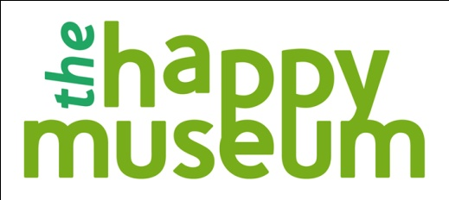

The Happy Museum Project - Open Application Commissions

Application Form

- The information submitted on this form is strictly confidential.
- Please complete all sections and return this form electronically to info@happymuseumproject.org – please also send 4 unbound copies of the project by post to Tony Butler, Museum of East Anglian Life, Crowe St, Stowmarket, Suffolk IP14 1DL
- Please ensure that the title of your commission is written on the bottom left hand corner of every page (ie in the footer).
- Please keep a copy of this form.
- An acknowledgement will be sent to you on receipt of your application.
- Interviews for shortlisted applications will take place during the week of 15th October in London.

Closing date: Friday 5th October at 12 noon
(both hard and electronic copies)

1. Title of your proposed Commission

2. Details of Lead Organisation and named Champion

Name of Organisation:

Website address:

Named Champion:

Address:

Telephone number:

Email address:

3. Details of any Partner Organisation(s) (if any) - and named Champion in each

Name of Organisation:

Named Champion:

4. Please outline the idea/proposal for which you are seeking financial support through the Happy Museum commissioning scheme and explain how it will address the key themes of the Happy Museum project. (up to 800 words)

5. Describe the impact that this Commission will have – what changes will occur? What will success look like and what resources will you commit to measuring and learning? This should be integral to your Commission. (up to 300 words)

6. How would this commission and your organisation/champion(s) contribute to the development of a Community of Practice? How will you disseminate information about your Commission and to whom? (up to 300 words)

7. If you were to receive financial support towards a commission, what are the main challenges that you would face, and how would you approach them? How would you assess your capacity and that of your organisation(s) to realise the ideas that you are proposing? (up to 300 words)

8. Budget - Please attach a draft budget for the proposed activity. Please specify the amount you are seeking from the Happy Museum fund and include details of any other potential funding you would apply to this project and whether it is confirmed or potential. Please identify a named budget holder. (1 page maximum)

9. References - Please provide details of two individuals who can give an informal view of the work of your lead partner. We may wish to contact them during the selection process. Please indicate if you would like us to check with you before contacting these referees.

Please do not include any additional information or attachments either in hard copy or electronically.

I confirm that the information I have provided in this application is true and accurate to the best of my knowledge.

Signature: Date:

(All decisions made by the Happy Museum Project are final and are not subject to review or appeal.)

Please complete all sections and return this form electronically to info@happymuseumproject.org – please also send 4 unbound copies of the project by post to Tony Butler, Museum of East Anglian Life, Crowe St, Stowmarket, Suffolk IP14 1DL

Closing date: hard and electronic copies must have been received Friday 5th October at 12noon

Interviews for shortlisted applications will take place during the week of 15th October in London

