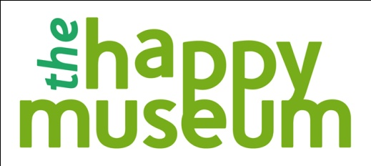

The Happy Museum Project - Open Application Commissions

Background

Research in psychology has shed new light on the factors that lead people to feel their lives are fulfilling, meaningful and worthwhile. One important finding to emerge from this research is that material goods play considerably less of a role in determining well-being than our spending patterns might suggest. For many people the pressure to “keep up” in consumption terms has been actively detrimental to real well-being and perhaps even a factor in increased risk of mental illness. Or as psychologist Oliver James puts it, our society is suffering from Affluenza

Led by Tony Butler, Director of the Museum of East Anglian Life, and funded through the Paul Hamlyn Foundation’s Breakthrough Fund, the Happy Museum Project is seeking to create a community of practice in UK museums committed to supporting transition to a high well-being, sustainable society. This will be stimulated by a series of activities to take place during 2011-13 beginning with the launch of the paper, The Happy Museum. The paper co-written by the New Economics Foundation and leading museum commentators is intended as a provocation to museums to think about how they might become high-well being organisations. A copy of the paper can be found on the Happy Museum website here.

Alongside the launch of the paper a fund of £60,000 is available to museums to demonstrate that the principles of happiness and well-being can leave a legacy of cultural change within their organisations or communities. The commissioned work will be informed by the ‘manifesto for well-being’ which concludes the Happy Museum

Other stimuli to develop a community of practice will include a 2-3 day symposium which will introduce the commissioned projects and leading thinkers from museums to people with a psychology and social policy background who have developed work around subjective well-being.

The commissioned projects and reports from the Symposium will be disseminated via the Happy Museum website, connecting people interested in the approach. The project will conclude with a Conference towards the end of the commission period which will ‘round up’ the commissioned projects and establish a way forward to further embed the principles within the sector.

Proposed commissions should meet the following criteria

- The proposal will be UK or Ireland based – although it could have involvement or impact beyond those borders.
- The proposal should be about new work.
- The proposal should show how museums can support transition to a high well-being, sustainable society - addressing at least 4 of the 8 manifesto principles outlined in the The Happy Museum.
- The lead organisation must be a museum (accredited or working towards Accreditation under the MLA scheme)
- A named Champion must be identified in the lead organisation and any partner organisation(s). The Champion(s) will actively contribute to an ongoing Community of Practice (including participation in evaluation, blogging, symposium and conference and general advocacy)
- A named budget holder will be identified
- Funding per commission will be between £6k and £20k. Proposals are encouraged which seek a level of funding appropriate to the scale of the Commission.
- The budget can include additional funding from other sources but the core context and ethos of the proposal must be driven by the Happy Museum Project commission.
- The proposed activity should be (substantively) finished by Jan 2013

Successful commissions will demonstrate the following:

- A clear understanding of the context and ethos of the Happy Museum
- Clarity around how the proposal addresses the key themes and manifesto principles identified in The Happy Museum Paper
- A clear picture of change – ie what success will look like and how it will be measured.
- How the proposal and the named champion(s) will contribute to the community of practice (including evaluation, blog, symposium and conference, general advocacy,)
- Plans for evaluation and dissemination.
- An understanding of potential risks and how these would be overcome.
- A clear budget, appropriate to the scale and ambition of the proposal.

March 2011

